**AIR QUALITY ANALYSIS**

**PHASE 2: INNOVATION**

This research is aimed at developing a monitoring system for SO2 levels and any influencing environmental factors such as air temperature, humidity and wind speed, using wireless sensor networks. The design will also enable delivery of near real-time data and information that can be accessed from personal computers and smartphones.

**SYSTEM DESIGN**

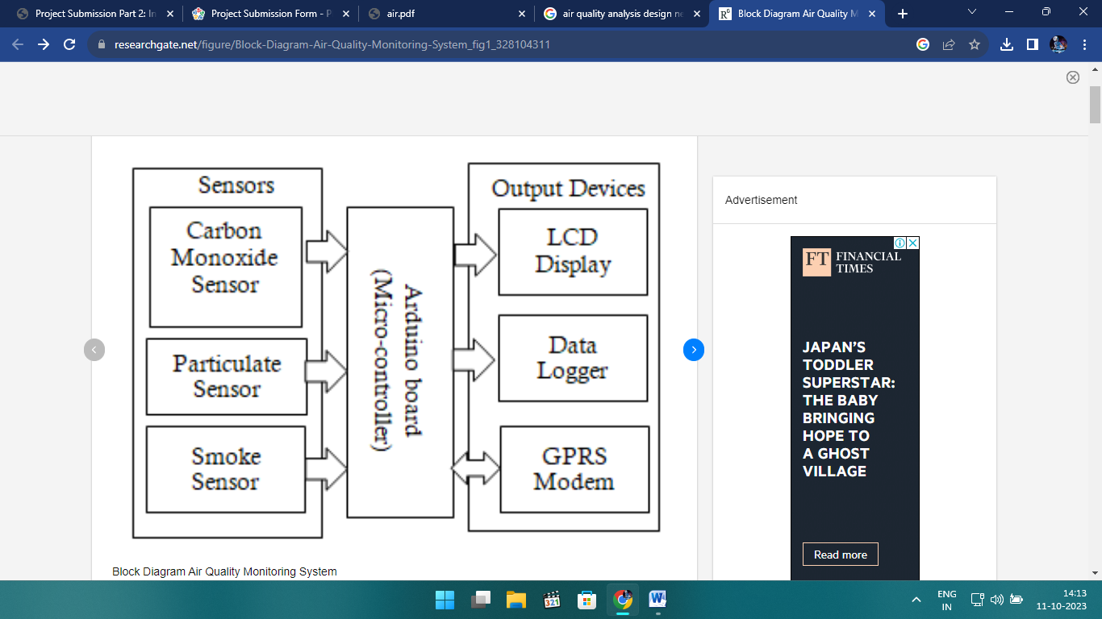

**MODULES**

CARBON MONOXIDE SENSOR:

A carbon monoxide (CO) sensor is a device designed to detect and measure the presence of carbon monoxide gas in the environment. Carbon monoxide is a colorless, odorless, and tasteless gas that is produced as a byproduct of incomplete combustion of carbon-containing fuels, such as natural gas, gasoline, wood, and coal. It is highly toxic and can be life-threatening if it accumulates in enclosed spaces.

PARTICULATE SENSOR:

A particulate sensor, also known as a particle sensor or particle counter, is a device used to measure and monitor the concentration of particulate matter (PM) in the air. Particulate matter refers to tiny solid or liquid particles suspended in the air, which can vary in size and composition. These particles can come from various sources, including industrial processes, vehicle emissions, construction, and natural sources like dust and pollen.

SMOKE SENSOR:

A smoke sensor, also known as a smoke detector or smoke alarm, is a device that is designed to detect the presence of smoke in the air. It is an important component of fire detection and safety systems. Smoke sensors are commonly found in homes, businesses, and industrial settings to provide early warning of a fire, allowing people to evacuate and take appropriate action to mitigate the danger.

LCD DISPLAY:

An LCD (Liquid Crystal Display) is a type of flat-panel display technology that is commonly used in a wide range of electronic devices, including computer monitors, television screens, smartphones, tablets, and more. It works by using the properties of liquid crystals to control the passage of light through the display.

LCD displays have several advantages, including their thin profile, energy efficiency, and the ability to produce high-resolution images. However, they also have some limitations, such as limited viewing angles, potential motion blur in fast-moving scenes, and lower contrast ratios compared to other display technologies like OLED (Organic Light Emitting Diode) displays.

OLED displays have become increasingly popular in recent years due to their improved contrast ratios and faster response times, but LCDs are still widely used in many devices due to their cost-effectiveness and versatility.

DATA LOGGER:

A data logger is an electronic device or system designed to record and store data over time. It is commonly used in various applications to monitor and collect information from sensors, instruments, or other sources. Data loggers are especially useful in situations where manual data collection is impractical, labor-intensive, or prone to errors.

Data loggers come in various forms, from small, portable devices to larger, stationary systems, depending on the specific needs of the application. The choice of a data logger depends on the type of data to be collected, the environmental conditions, and the required level of accuracy and reliability.

GPRS MODEM:

A GPRS (General Packet Radio Service) modem is a device that enables communication over the GPRS network, which is a 2G mobile data service. GPRS is a packet-switched technology that allows for data transmission over mobile networks, making it possible to send and receive data over a cellular connection, including text messages, email, and internet browsing.

GPRS modems were more commonly used in the early 2000s when faster data technologies were less widespread. Today, for most data-intensive applications, users tend to prefer 3G, 4G, or 5G modems for faster and more reliable data connectivity.